How to Update Employee Email Signature

- In Outlook, go to File menu and click on Options in the bottom left corner.

- In the window that pops up click on Mail in the left-hand menu.

- Click on the Signatures button on the right-hand side next to the “Create or modify signatures for message” section.

- Remove any content from the Edit Signature box. Copy/paste the new signature information on page 2.

- Highlight “email” with your mouse and click on the link icon above the signature box field.
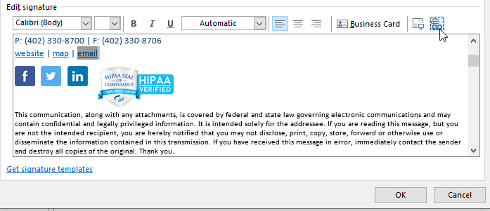

- In the Insert Hyperlink box, click on Email Address from the left-side menu. Type your email address in the “E-mail address” field. Hit ok.
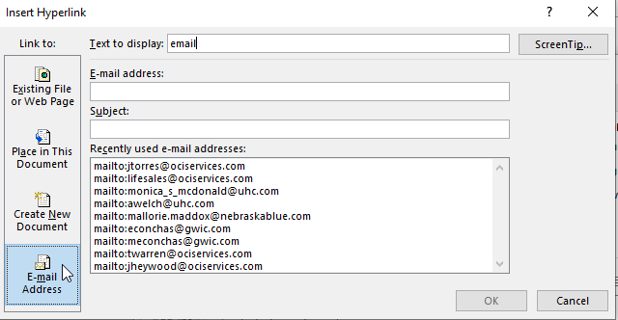

- Change the font color to match the other links by highlighting “email” again and clicking on the font color drop down menu. Select a light blue to match.

- Hit Ok to Save. If you have any questions, please consult the OCI helpdesk.

EMPLOYEE NAME | Employee Title
4221 N. 203rd St, Suite 200 | Elkhorn, NE 68022
P: (402) 330-8700 | F: (402) 330-8706
website | map | email
Follow us on social media:
This communication, along with any attachments, is covered by federal and state laws governing electronic communications and may contain confidential and legally privileged information. It is intended solely for the addressee. If you are reading this message, but you are not the intended recipient, you are hereby notified that you may not disclose, print, copy, store, forward or otherwise use or disseminate the information contained in this transmission. If you have received this message in error, immediately contact the sender and destroy all copies of the original. Thank you.

